Hello All!

If you’re reading this wondering whatever am I going to do today then you’re in luck! I thought I would share with you a number of STEM activities which you can attempt on your own or with whomever you’re stuck in isolation with. Give them a go and see where the Science takes you! Science is not just in the classroom it’s everywhere.

Hope you are all safe and well,

Mr Kirk

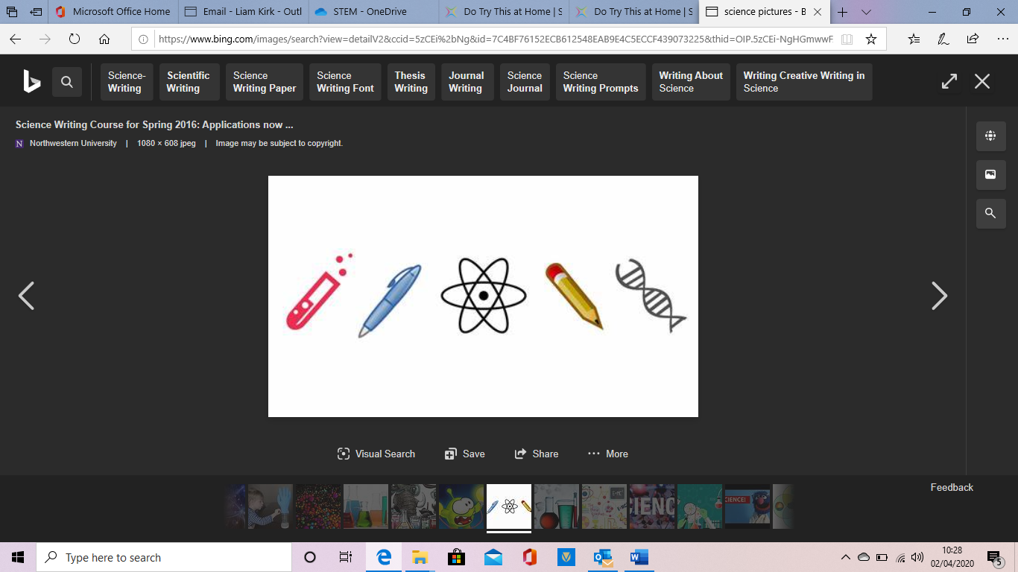
Measuring sixty seconds

These short activities challenge participants to measure 60 seconds in many different ways.

Activity 1
Design a track to make a marble roll for exactly sixty seconds

Using simple materials like egg cartons, cardboard, plasticine, tape, etc. design and make a track for a marble to roll along. Try to make the marble roll for exactly 60 seconds.

Activity 2
Reversing the sands of time - design a sixty second timer

Make a cone using acetate, stiff paper or card and tape. It needs to have a small hole at one end so that it acts as a funnel.

Hang the funnel over a container that is large enough to contain the material that you are going to pour through the funnel.

Use sand or another material that will move through the funnel into the container below.

The challenge is to design a 60-second timer. As a group challenge, which timer is the closest to 60 seconds? Try out different materials that will flow through the funnel, experiment with funnels that have different sized holes. How does this timer compare with human estimation? You can use these timers later to time the fun-sized science activities!

Activity 3
Text messaging
How long does it take to type a set message and send it?

Are there any intergenerational differences – what’s the difference between your grandparents and yourself. Think about why new technology might be challenging to the older generation.

Fun-sized science activities

You will need a group or groups of participants, and different science activities that can each be completed in one minute for this type of event. Having a 60-second time limit will add an element of excitement to the event. Individually, or in small teams, participants complete a circuit of science activities. Participants have one minute at each station to complete a task, gather information, or complete an investigation or experiment. They should record their findings at the end of each minute and at the conclusion solve a problem/puzzle or compare with other groups/individuals.

Activity 1

Construct a paper aeroplane or parachute, boomerang or a water rocket that stays in the air for 60 seconds.

Activity 2
Launch a film canister rocket in 60 seconds

Your challenge is to achieve a 60-second delay between priming and lift off! Please do this activity on a table or bench, in an area that has a high roof, and where it doesn’t matter if things get a little wet. Students will need to be supervised by adults during this activity.

Building your rocket:
You will need:

- a plastic film canister with a snug-fitting lid

- 1 Alka-Seltzer tablet

- some water (warm and cold).

Please do this activity on a table or bench, in an area that has a high roof, and where it doesn’t matter if things get a little wet. Students will need to be supervised by adults during this activity.

You will need to do the experiment quite quickly so it is good to familiarise yourself with the following procedure without the Alka-Seltzer tablet first.

Stand the film canister upright with the lid off. Break your Alka-Seltzer tablet into quarters and place one quarter in the bottom of the canister. Add a little water to the canister, about 1/3 full or less (experiment with this). Now quickly fit the film canister lid onto the top and seal completely. Turn the whole canister upside down so that the lid is touching the table and wait….Your challenge is to aim for a 60 second delay between priming and lift off!

What happens?

The Alka-Seltzer tablet will react with the water and produce a gas as part of this reaction, as more gas is produced the pressure of the gas forces the lid and the canister to separate. The canister should launch high into the air. Now experiment using warm water or cold water, or experiment with the amount of water that you add to the Alka-Seltzer tablet.

Chemistry notes:

Alka-Seltzer tablets contain aspirin, sodium bicarbonate, citric acid (in solid form) and mono-calcium phosphate. When water is added to the Alka-Seltzer tablet the citric acid

Download more activity packs for National Science & Engineering Week at www.nsew.org.uk

ionises to produce hydrogen ions (H+ aq) which react with the bicarbonate (HCO3 aq) to produce carbon dioxide gas (CO2) and water (H2O). The reaction leaves a solution of sodium citrate, i.e. sodium ions and citrate ions in solution.

Activity 3
Puzzles that stretch the mind, for example maths puzzles, like a tangram or Möbius strip

Making a Möbius strip:
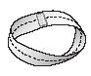

Take a strip of paper. Twist the paper once then join the two ends so that you make a circle with one twist. This is a Möbius strip. Draw a line along the middle of the strip, you will find that you can draw on the outside AND inside of the strip - without your pen leaving the paper!
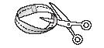

Using scissors, cut along the line down the middle of the Möbius strip, what do you make? Repeat and repeat with the same Möbius strip – how many times can you do this and what can you make in 60 seconds?

Variations:

- Give the Möbius strip two twists before joining the two ends together, then cut down the middle.

  - Make a Möbius strip and cut one-third the width of the strip away from the edge. Keep cutting along this line until you come back to where you first started cutting. Have you made a necklace with a pendant?

  - Tape a circular strip and a Möbius strip together so they are perpendicular. Cut down the middle of the circle, right through the join, then through the middle of the Möbius strip right around – can you make a square?

    - Tape two Möbius strips together one perpendicular to the other, now cut down the middle of one, and then the other – what do you make? Try this when the Möbius strips are taped together so they are parallel.
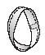
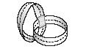

Activity 4
Chromatography

You will need a collection of black pens, coffee filter paper or blotting paper, cups or beakers, water, Smarties and a dropper.

Mark a large dot with each pen near the bottom of the paper (approximately 1cm diameter). There should be a little space between the bottom of the paper and the dot.

Next stand the paper in a beaker or cup with a small amount of water so that the marked dots are just above the water. Watch the water soak up the paper and into the ink. What happens after 60 seconds?

Now try placing a Smartie stain or ink blob in the middle of the paper. Rest the paper on top of the beaker or cup and carefully drip water on the centre of the stain/ink blob. What happens after 60 seconds?

Download more activity packs for National Science & Engineering Week at www.nsew.org.uk

Activity 5
Bubbles

Make up your bubble mixture using detergent and warm water. You may also wish to add a little sugar or glycerine to this mixture. Experiment with the type and amount of detergent in the solution – you will need less of this than you imagine but each type of detergent will be different.

- How many bubbles can you blow in 60 seconds?

- Can you make a bubble last for 60 seconds?

Making your bubbles:

Make up your bubble mixture using detergent and warm water. You may also wish to add a little sugar or glycerine to this mixture. Experiment with the type and amount of detergent in the solution – you will need less of this than you imagine but each type of detergent will be different.

Recipe for bubbles:

Add warm water to a plastic container. Now carefully stir in the glycerine, sugar or corn syrup to the water. Start with a ratio of 1 part glycerine to 20 parts water. Dissolve the sugar in the water first.

Slowly add the detergent to the mixture. Start with a ratio of 1 part detergent to 10 parts water. The mixture should be well combined but not shaken – try not to create any froth on the top. (You may also like to try a ratio of 1 part detergent to 5 parts water)

Hint: Bubble solution gets better after it sits for a while, so make the mixture up a couple of hours, or the day before you want to use it.

Activity 6
Build a structure in 60 seconds

Each team receives the same information to build a structure of a set shape (e.g. cube or pyramid) using given materials in 60 seconds. Teams then combine their structures at the end to build one very big version! For example, use pieces of short wooden dowel and sticky tape to make a triangle-based pyramid and then combine the pyramids to make one large one.

The British Science Association Young People’s team use spaghetti and marshmallows for this challenge!

Activity 7
Balancing science

Can you balance on one leg for 60 seconds? Can you balance on one leg with a bag of sugar in one hand held out sideways?

Download more activity packs for National Science & Engineering Week at www.nsew.org.uk

Long-term time projects

Project 1
Research, write and produce a play about “The Big Bang”

What do scientists believe happened in the first sixty seconds of the Universe’s creation? Explore the cultural significance of time and the ways that different cultures around the world measure time. Research a brief history of time; you might include aspects of geological and ecological time, and animal lifecycles. How did the introduction of railways affect standardising time across the nation?

Project 2
Write a rap!

A rap – in groups write a 60-second rap about your favourite science topic. Perform it to the rest of the class!

Project 3

Research this question:” Why do we use 60 and multiples of it to measure time, angles and longitude?”

Activity ideas and resource information:

The National Physical Laboratory provides beginners guides to measurement; they are also available as posters.

www.npl.co.uk/npl/publications/posters.html

