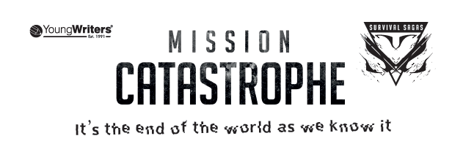

Name: Surname: Age:
Teacher’s Name: Tutor Group:
School Name:
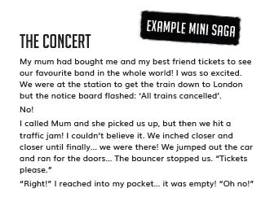
School Postcode:

Story Starters
You can use one of these to start or inspire your work.
- I didn’t mean for this to happen
- “Breaking news, the prime minister has declared…”
- Was I the only one left?
- “Emergency! Evacuation plan activated…”
- Everything went dark…
- The thick smoke was choking…
- I was having the worst day ever
- One text changed everything…

TITLE:
(Not included in your 100 words)
Type your story here:

