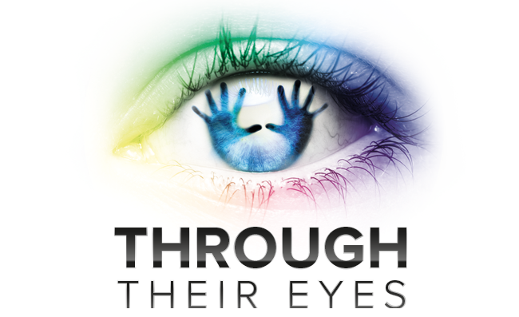
Planning Sheet

Whose point of view are you writing from?

Write 3 words to describe your person:

1.

2.

3.

What key points do you want to raise or tackle in your poem?

What tone will you use? E.g. Sad, ironic, joking, aggressive, happy, etc.

What type of poem will you write? E.g riddle, free verse, haikus, etc.

What poetic techniques will you use?
E.g. Imagery, personification, rhyming couplets, etc.

Student Entry Form

Name: Surname: Age:

Teacher’s name: MISS L KINSELLA Tutor Group: LIBRARY

School Name: ST JOHN BOSCO ARTS COLLEGE
Postcode: L11 9DQ

Poem Title:
Write your poem here… Use the planning sheet to help plan your poem!

