Poetry Heroes Competition 2024
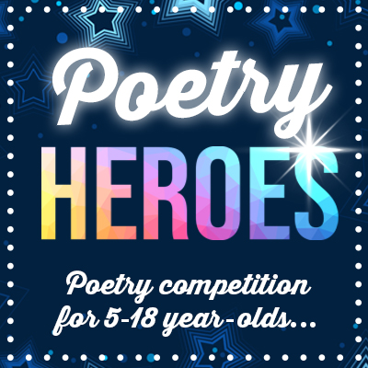
Young Writers are inviting you to write a poem about your favourite person for the latest competition – Poetry Heroes.
Who is your hero? Is it your mum or dad? Your best friend? Your brother or sister? Perhaps there is a famous person, from a sports or film star to an author or musician, that you admire and aspire to be like.
Why are they your favourite person and why do they inspire you?
Grab your pen and get writing! From haikus and rhymes to acrostics and everything in-between, Young Writers welcome your poem in any style and format celebrating your poetry idol.
PRIZES
Selected poems will feature in a special anthology and Young Writers favourite poet will win a selection of books!
ENTER
Use the Planning Sheet (attached) to help you and complete the Student Entry Form (word document attached) and return to Miss Kinsella via school email before the closing date. Deadline for entries is Friday 31st May 2024.

